6th Grade News
Week of May 3, 2010

Field Trips

Please send in all field trip permission slips as soon as possible so we can make plans. You may send the money in later if needed.

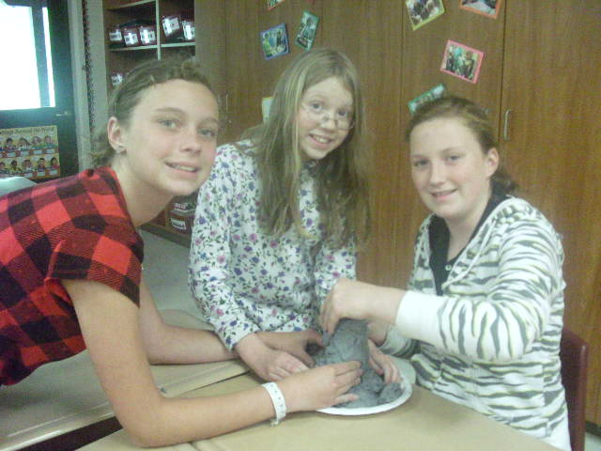
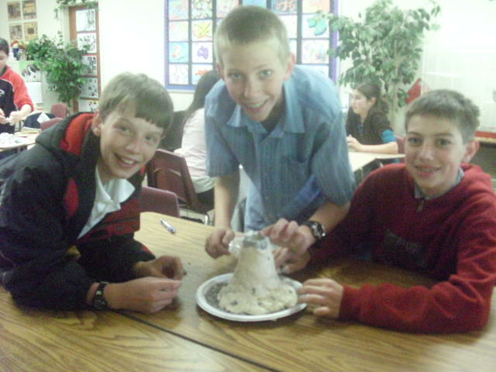
Bible
There will be a quiz this Friday on
James 1:2-11
(2-3) Consider it pure joy, my brothers, whenever you face trials of many kinds, because you know that the testing of your faith develops perseverance. (4-5) Perseverance must finish its work so that you may be mature and complete, not lacking anything. If any of you lacks wisdom, he should ask God, who gives generously to all without finding fault, and it will be given to him.
(6-8) But when he asks, he must believe and not doubt, because he who doubts is like a wave of the sea, blown and tossed by the wind. That man should not think he will receive anything from the Lord; he is a double-minded man, unstable in all he does. (9-10) The brother in humble circumstances ought to take pride in his high position. But the one who is rich should take pride in his low position, because he will pass away like a wild flower. (11) For the sun rises with scorching heat and withers the plant; its blossom falls and its beauty is destroyed. In the same way, the rich man will fade away even while he goes about his business.
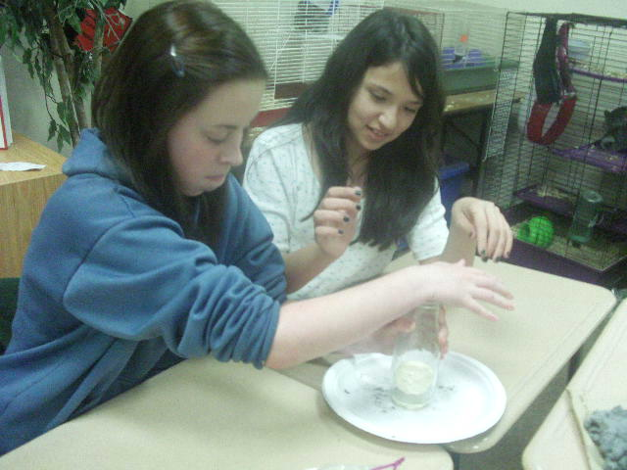
Spelling

- since
- sense
- choose
- chose
- finally
- finely
- except
- accept
- beside
- besides
- recent
- resent
- access
- excess
- later
- latter
- metal
- medal
- personal
- personnel


Writing

The last section of the autobiography is due this Friday. The final project will be due on May 21st. Please bring a sampling of your favorite family recipe to share with your classmates along with your project.

Due Dates

Science Test – May 4
Book Report – May 19
Autobiography – May 21

Dates to Remember

May 3
Open House/Book Fair
Science Fair Projects Due

May 6
Shasta Caverns Trip

May 7
Speech Meet
Pancake Breakfast

May 10
Pajama Day

May 11
Small Business Fair

May 14
Western Day

May 25
Rescue Mission Field Trip

May 27-28
Ecology Camp

